Name: Pich Lyhong

ID: e20190847

Group: I4-GIC-B

**TP14 Assignment**

**Git url:** <https://github.com/LyhongPich/TP-Internet-Programming/tree/TP14>

# Ex1: Constant Definition in PHP

* Source code:

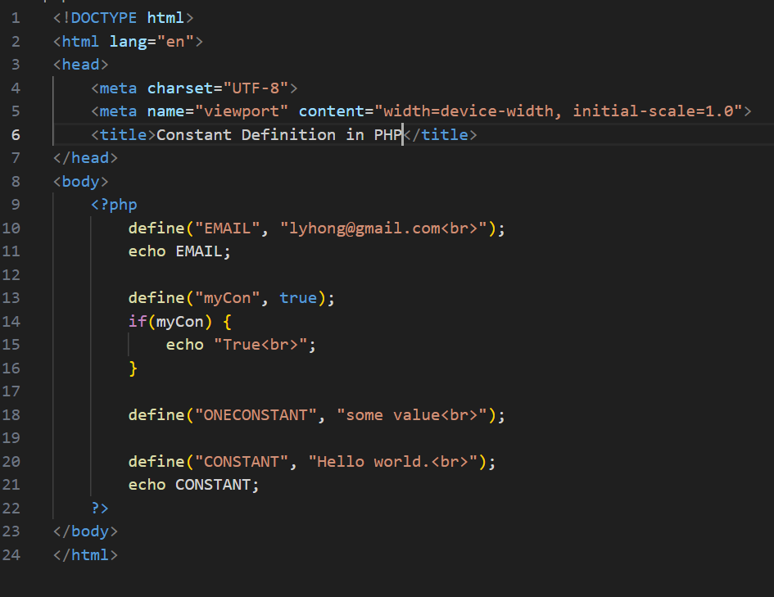

* Result:

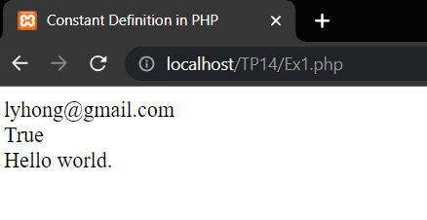

# Ex2: String Concatenation in PHP

* Source code:

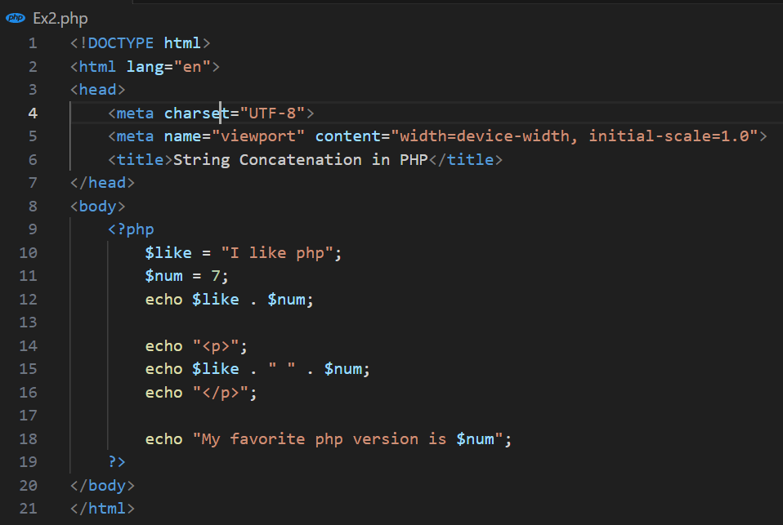

* Result:

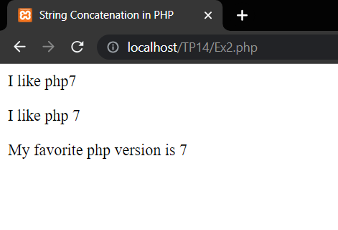

Ex3: Operators in PHP (Part1)

* Source code:

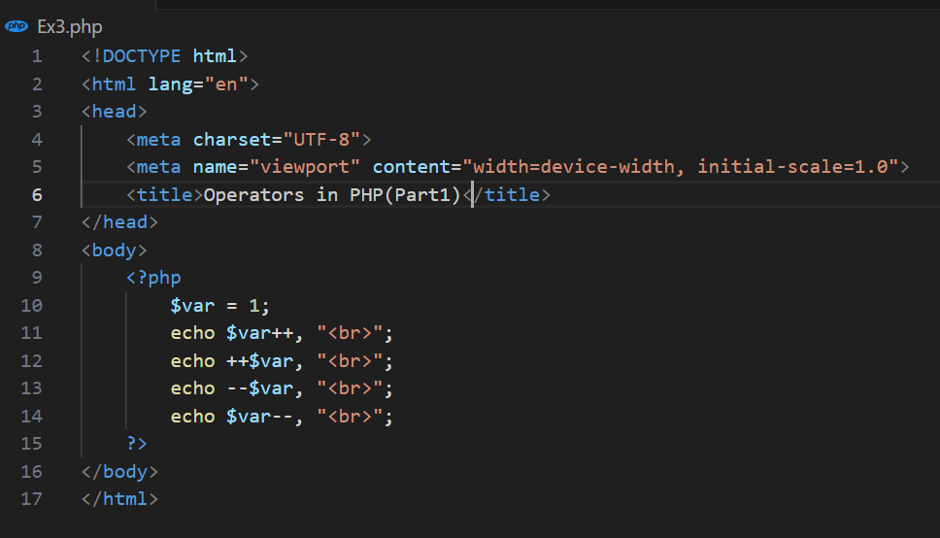

* Result:

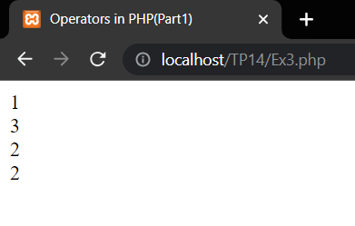

Ex4: Operators in PHP (Part2)

* Source code:

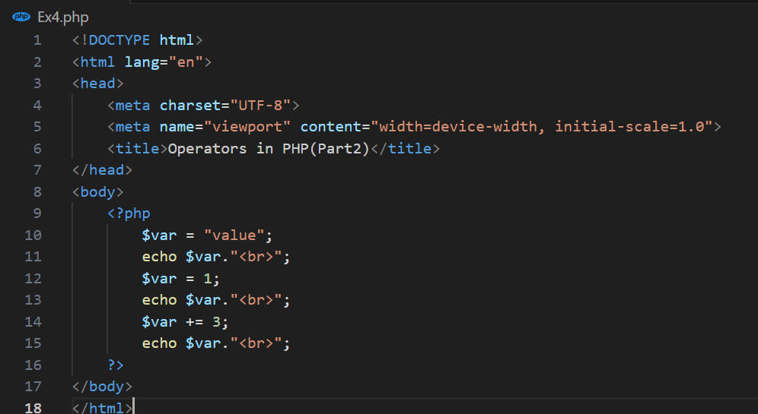

* Result:

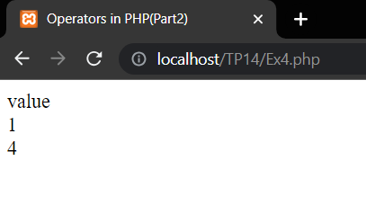

Ex5: Concatenation

* Source code:

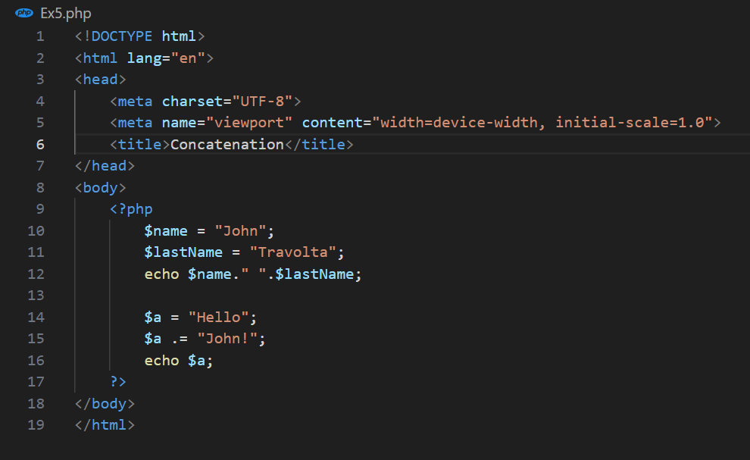

* Result:

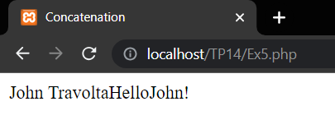

Ex6: PHP Decision Making (If-Else)

* Source code:

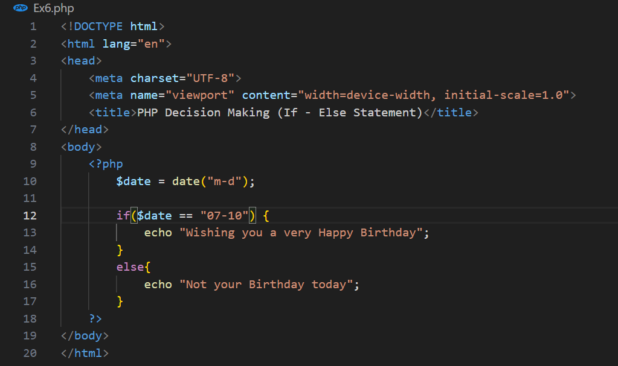

* Result:

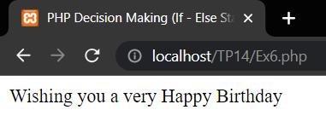

Ex7: PHP Decision Making (If-Elseif-Else)

* Source code:

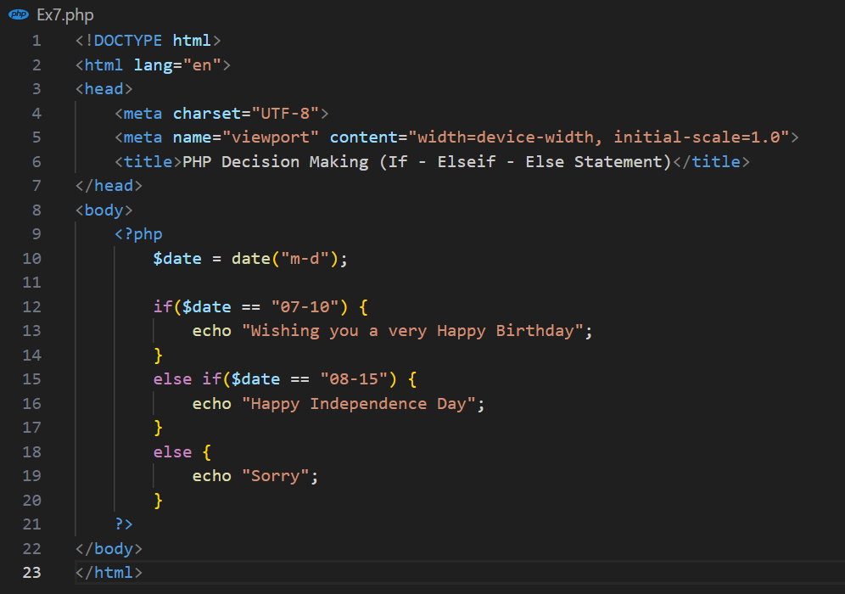

* Result:

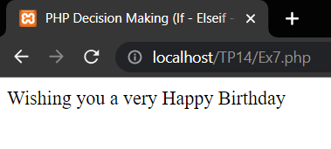

Ex8: PHP Decision Making (Switch)

* Source code:

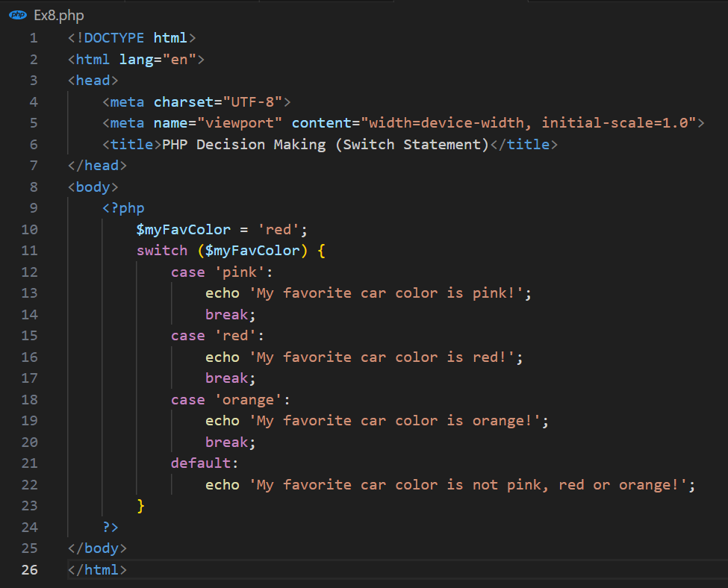

* Result:

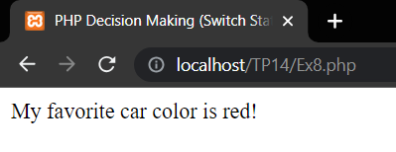

Ex9: PHP Loops (While Loop)

* Source code:

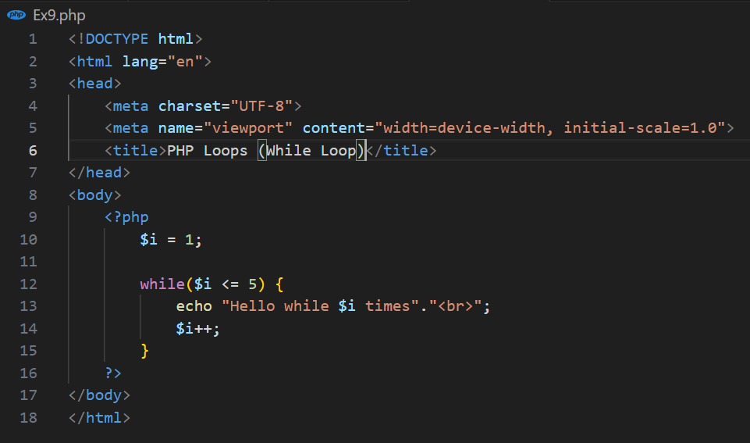

* Result:

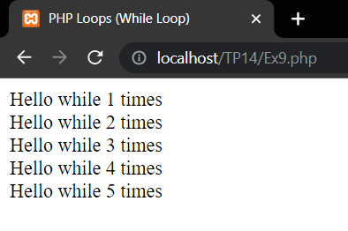

Ex10: PHP Loops (Do While Loop)

* Source code:

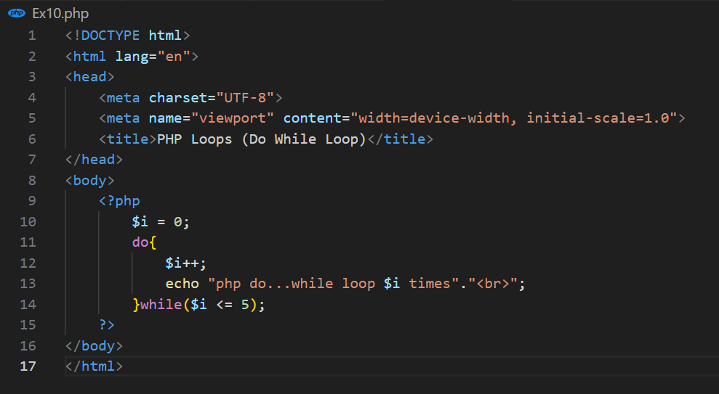

* Result:

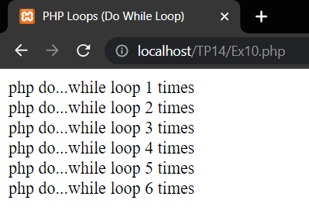

Ex11: PHP Loops (For Loop)

* Source code:

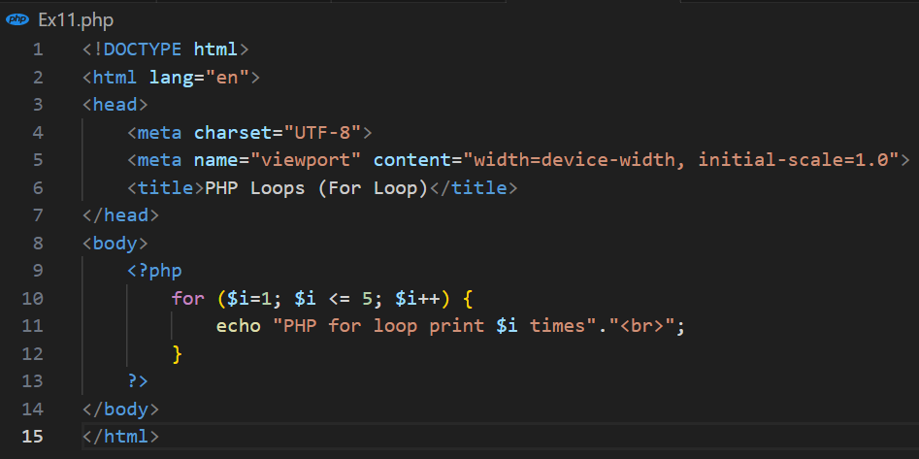

* Result:

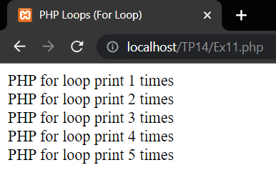

Ex12: PHP Loops (Foreach Loop)

* Source code:

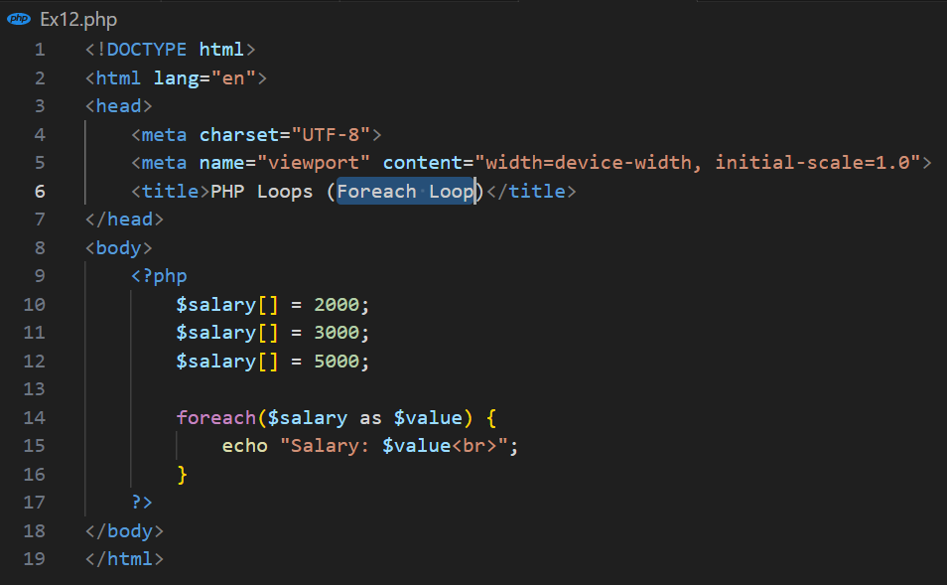

* Result:

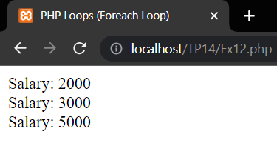

Ex13: PHP Array (Numberic Array)

* Source code:

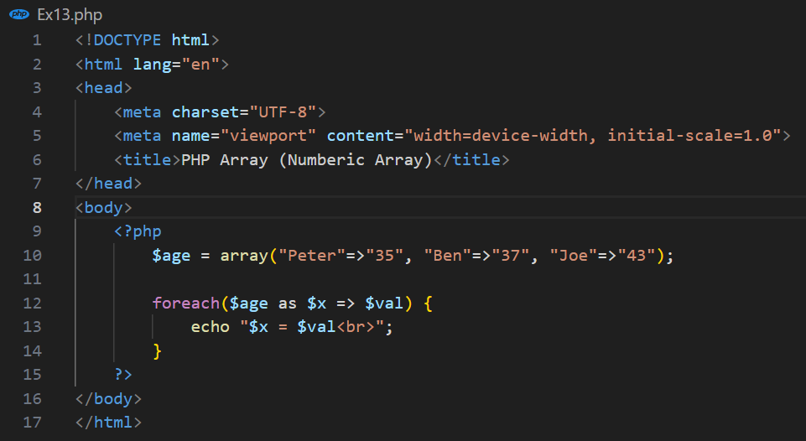

* Result:

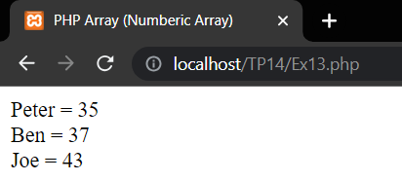

Ex14: PHP Array (Multi-dimensional)

* Source code:

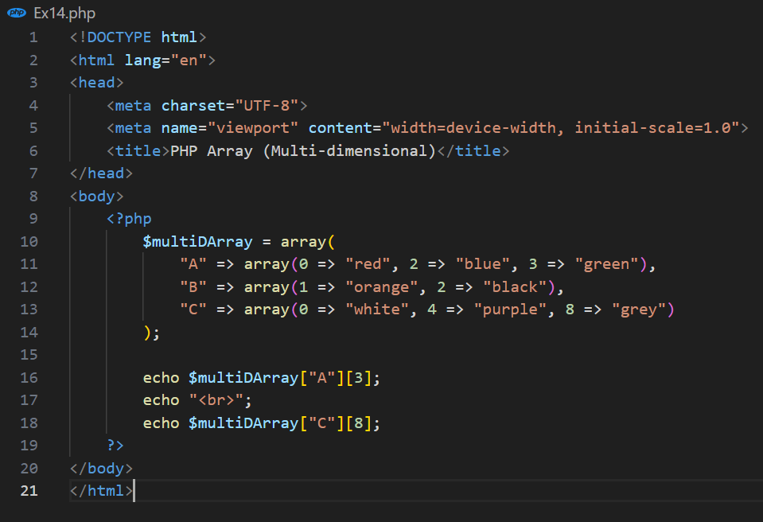

* Result:

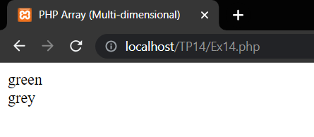

Ex15: PHP Session

* Source code:

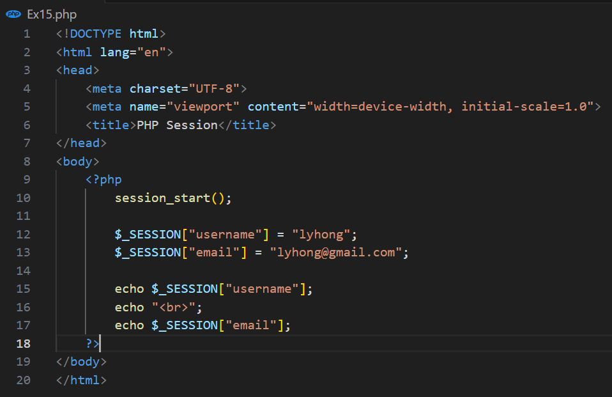

* Result:

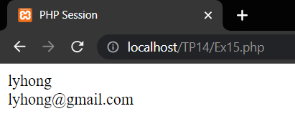

Ex16: PHP Post Form Handling

* Source code:

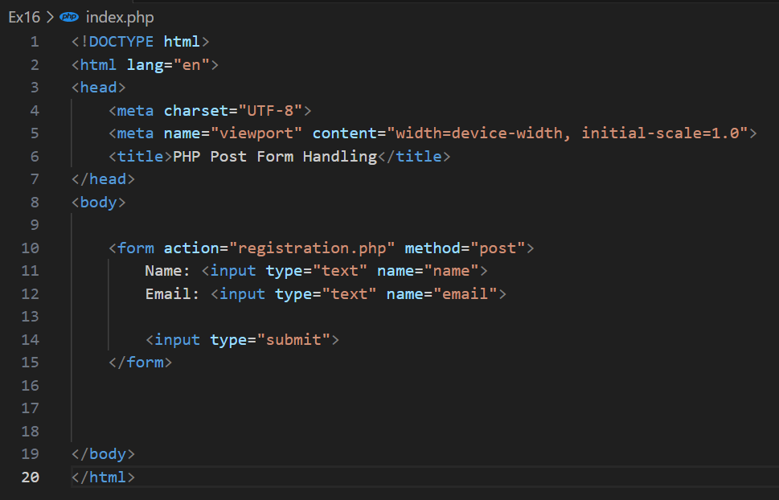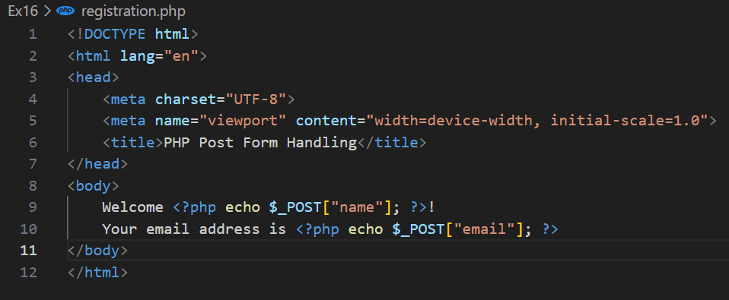

* Result:

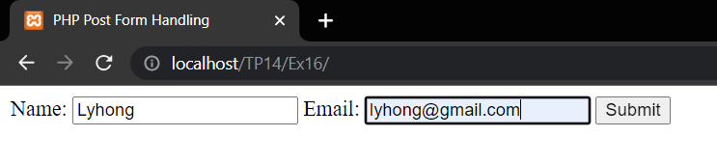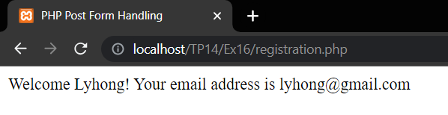

Ex17: PHP Get Form Handling

* Source code:

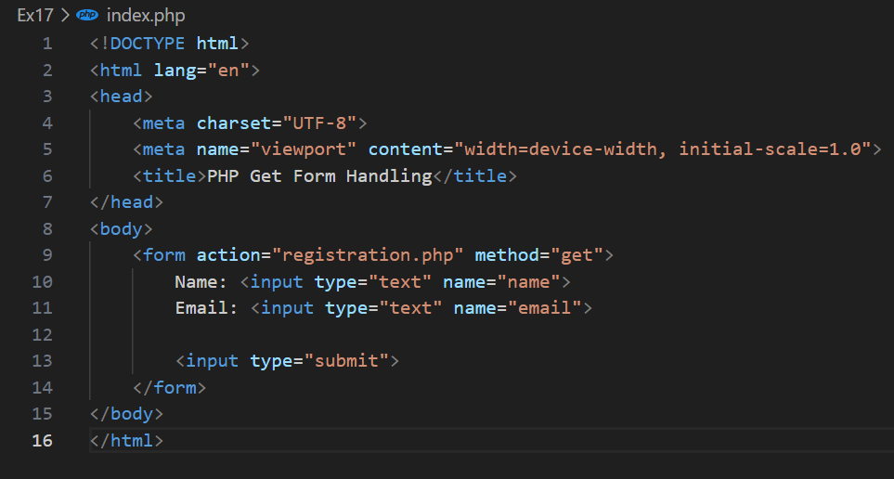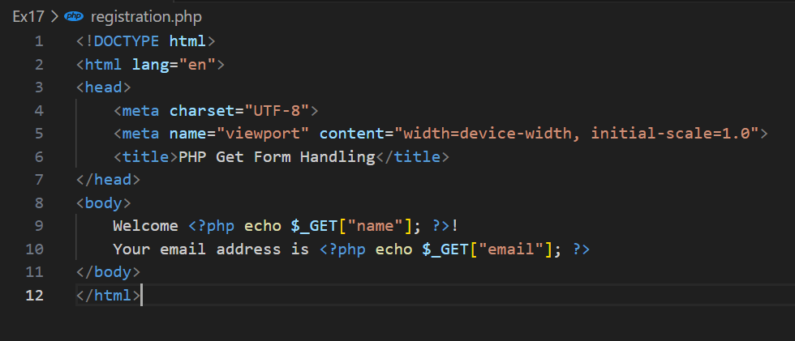

* Result:

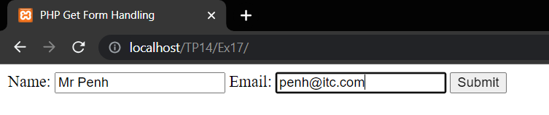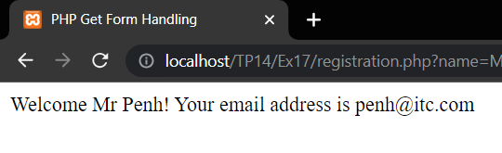

Ex18: Sample HTML Forms

* Source code:

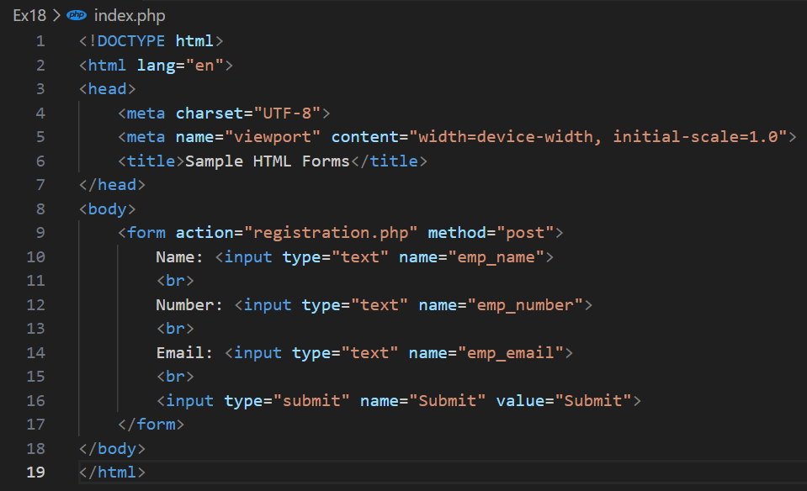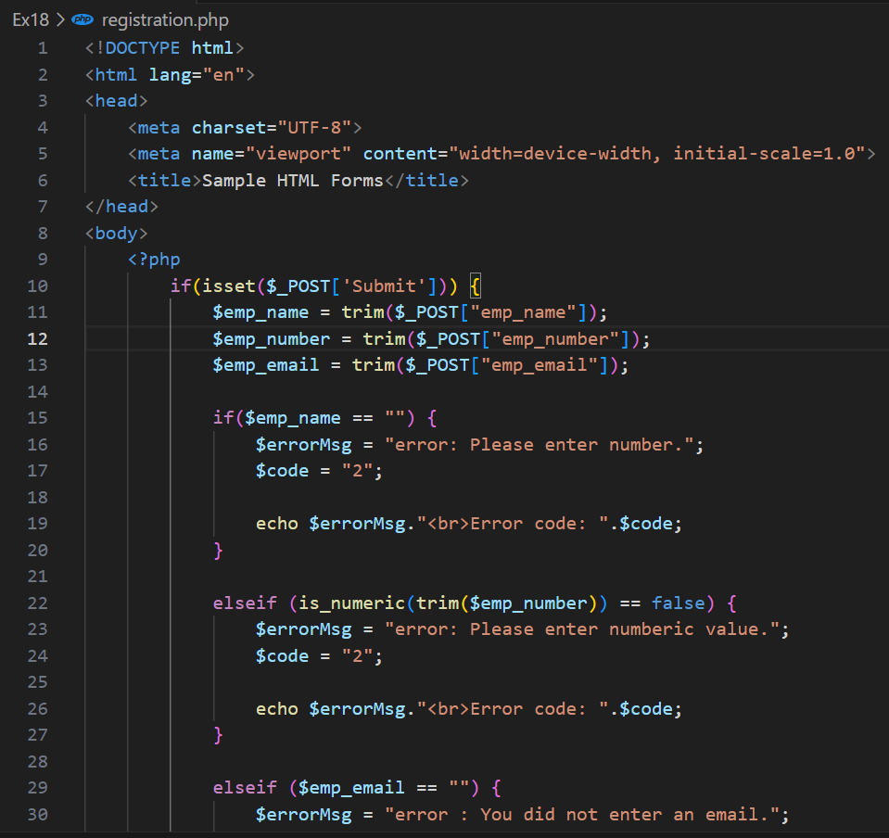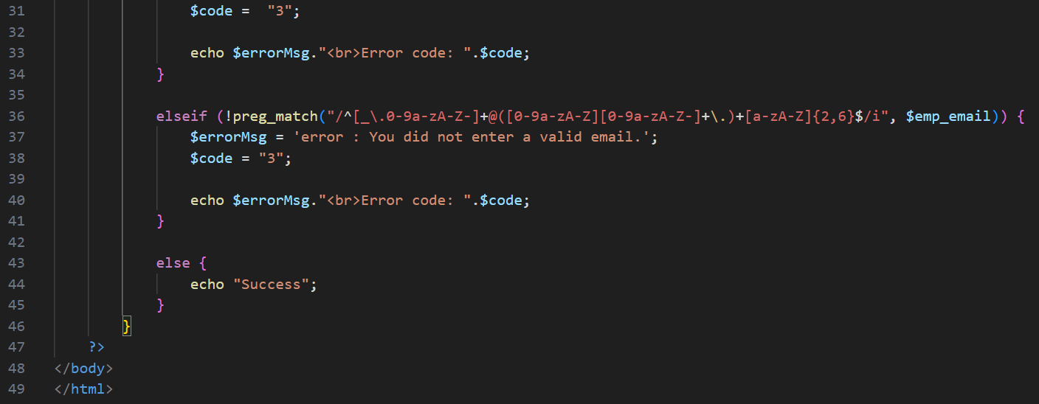

* Result:

